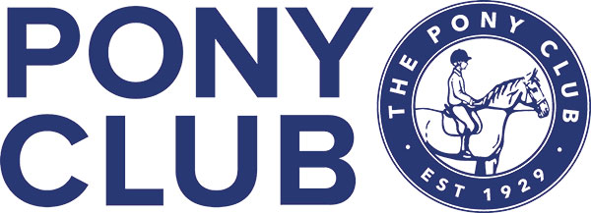
LORD LECONFIELD BRANCH OF THE PONY
Junior Camp @
Petworth Schooling Course
Horsham Road, Petworth, GU28 0HB

Dear All,
This year camp will be held at Petworth Schooling Course, Horsham Road, Petworth, GU28 0HB, by very kind permission of Simon Luck.
We hope to offer your child a fun and rewarding experience with valuable tuition, fun, games and entertainment over the four days. In order for all this to happen we will need some parent volunteers to supervise ponies during lunch etc and a rota will be sent out nearer the time. Otherwise we do ask that parents do not stay unless given prior authority.
There are 6 forms attached for you to download and fill in, with important information on, some of which need to be returned to me by no later than the 1st July 2019, that is the medical form, rider and pony information and your signed declaration.
We have kept the price the same as last year at £130 and payment must also be received to secure your child's place. This can be done by direct bank transfer using the reference juniorcamp/surname (Sort code 30-94-41, ACC 02217676). If you would rather pay by cheque, please make it payable to "Lord Leconfield Hunt Pony Club" and post to my address shown below. In either case, please confirm to me when payment has been made.
Your prompt replies would be greatly appreciated in order that we can plan and cater for the correct number of children. The 1st July will be the strict cut off date.
If you have any queries regarding Junior camp please do not hesitate to get in touch.
Best regards,
Anneli Flexman
Glebe Farm, Gay Street, Pulborough, West Sussex. RH20 2HN

